Importing MARC records from Library of Congress
https://catalog.loc.gov/ (I like to use Internet Explorer for this since it is easier to tell it where to save)
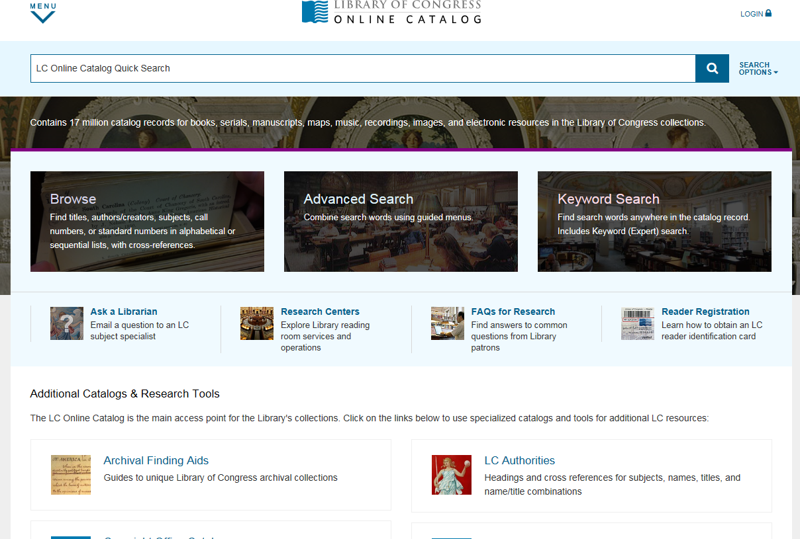
- Type the title or author of the book you are looking for in the Search Box. If you click on Search Options, you will be given the choice to go Advanced Search if you need to refine your Search.
- When you find your record, click on the link. 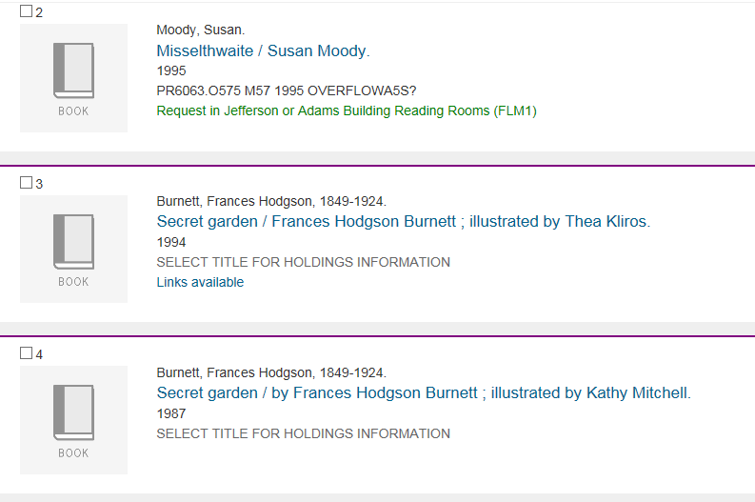
- When the new screen opens, click on Save Record on the right side of the screen. 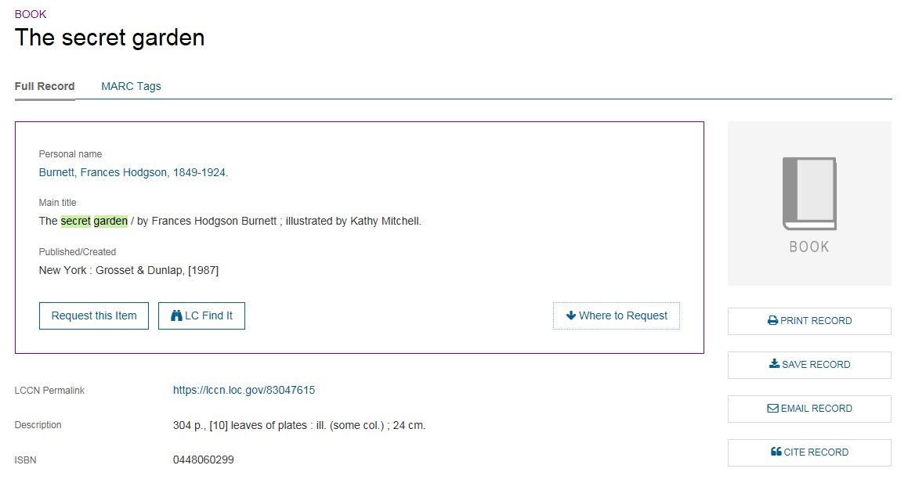
- Click on the drop-down arrow to select MARC (non-Unicode/MARC-8) and then click Save. 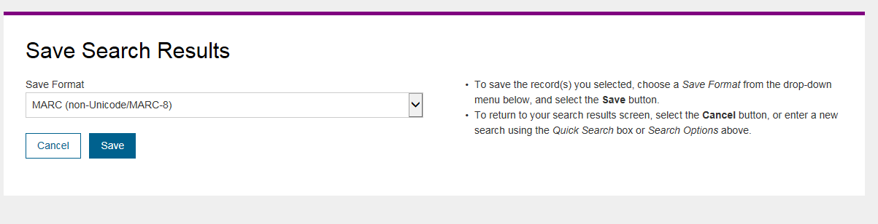

- A Task bar opens at the bottom of the screen. Choose Save As (Click on the drop-down arrow ) and then select where you want to Save the record. Click Save and then you are ready to import into Mandarin.

